Book Study
Enrique’s Journey by Sonia Nazario
Sept. 11, 18, 25, & Oct. 2
7:00-8:00 pm. In-person at MUMC and by Zoom
Pulitzer Prize winning true story and fast-paced read about a young person’s repeated attempts to flee Honduras and reunite with his mother in the United States.
This story opens our eyes, our hearts, and our minds to the unimaginable risks immigrants experience to become strangers in strange lands
Open your hearts and join us for a great read!

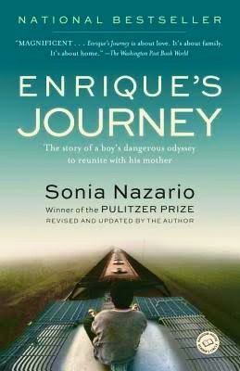

This book is available through Amazon.

